Homework 5

BY: NOA SHADMON

ID: 5980

**Honor Code: ``The codes and results derived by using these codes constitute my own work. I have consulted the following resources regarding this assignment:'' (ADD: names of persons or web resources, if any, excluding the instructor, TAs, and materials posted on course website)**

Kathleen Zhen, code posted on piazza, and discussion notes (posted by Nick)

**Problem 1**

The first time we run the code, we get $β_{0}=-5.071102$ and $β_{1}=2.016006$ with $σ^{2}=0.9827592$. For all 10 runs, the theoretical confidence interval for $β_{0}$ is always greater than that for bootstrap procedure. This is also true for $β_{1}.$ This is again seen when we calculate the average values for the slope and intercept coefficients for the theoretical and bootstrap samples. The average theoretical $β_{0}$ = 0.830346 and the average bootstrap $β_{0}=0.6838061$. The average theoretical $β_{1}$ = 0.1230048 and the average bootstrap $β_{1}=0.1046841.$

**Problem 2**

Using the logistic model, we created a confusion model. Of the 20 plants (using Sepal.Length as the predictor), the system predicted 12 setosa plants and 8 versicolor plants even though there are 10 of each. This model is 90% accurate (code to calculate accuracy attached). 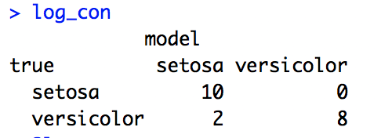

Using the linear discriminant analysis the system predicted 13 setosa plants and 7 versicolor plants (using Sepal.Length as the predictor). This model predicted 85% correctly.

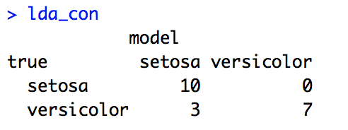

Using the k nearest neighbor’s algorithm, when k=3 the confusion matrix is as such:

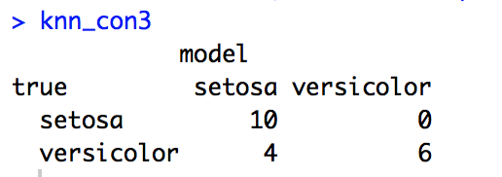

Here, the system predicted 14 setosas and 6 versicolor. This model is 80% accurate. When k=5, the confusion shows a prediction of 12 setosas and 8 versicolors. This model is 90% accurate.

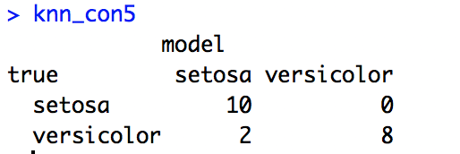

From the tables and using the calculated accuracy values, we can conclude that the logistic model and k nearest neighbors (with k = 5) is the best for classification prediction when sepal.length is the predictor.

APPENDIX

library(readr)

library(broom)

library(MASS)

library(class)

#PROBLEM 1

resample = function(data) {

n = nrow(data)

# Sample row numbers (i) rather than values (e_i)

idx = sample(n, n, replace = TRUE)

# Use row numbers to get new residuals (e2_i).

res_samp = data$.resid[idx]

# y2_i = b_0 + b_1 * x_i + e2_i

y_samp = data$.fitted + res_samp

# Insert new response (y_i) into data frame, keeping old covariates (x_i)

data$gift_aid = y_samp

# Fit the same model with new data (y2_i, x_i).

new_mod = lm(gift_aid ~ x, data)

return (coef(new_mod))

}

prob1 = function(seed) {

set.seed(seed) # only set the seed once, at the beginning

# Part 1

x = rchisq(n = 100, df = 6)

e = rnorm(n = 100, mean = 0, sd = 1)

y = -5 + 2*x + e

# Part 2

mod = lm(y ~ x)

summ = summary(mod)

print(summ$coefficients)

sigma = summ$sigma

print(sigma)

resid = augment(mod)

# Part 3

theo = confint(mod)

boot = sapply(1:400, function(i) resample(resid))

ci_intercept = quantile(boot[1, ], c(0.05, 0.95))

ci_slope = quantile(boot[2, ], c(0.05, 0.95))

theo_diff_int = abs(theo[3] - theo[1])

theo_diff_x = abs(theo[4] - theo[2])

diff_int = abs(ci_intercept[[1]] - ci_intercept[[2]])

diff_slope = abs(ci_slope[[1]] - ci_slope[[2]])

ci_widths = data.frame(theo_diff_int, theo_diff_x, diff_int, diff_slope)

# Return widths of both the theoretical and bootstrap confidence intervals:

return (ci_widths)

}

all_ci_widths = sapply(1:10, prob1)

#average of theoretical intercept confidence interval

theo_avg_int = mean(as.numeric(as.vector(all_ci_widths[1,])))

#average of theoretical slope confidence interval

theo_avg_x = mean(as.numeric(as.vector(all_ci_widths[2,])))

#average of boot intercept confidence interval

diff_avg_int = mean(as.numeric(as.vector(all_ci_widths[3,])))

#average of boot slope confidence interval

diff_avg_slope = mean(as.numeric(as.vector(all_ci_widths[4,])))

#part 2

data(iris)

data = iris[1:100,]

test = rbind(data[41:50,], data[91:100,])

training = rbind(data[1:40,], data[51:90,])

test = droplevels(test)

training = droplevels(training)

log_model = glm(Species ~ Sepal.Length, training,family = binomial)

# Predict for test data. Use type = "response" to get class probabilities.

log_pred = predict(log_model, test, type = "response")

# Convert predictions to 1 or 2, for category 1 or 2 respectively.

log_pred = (log_pred > 0.5) + 1

log_pred = levels(training$Species)[log_pred]

log_con = tabcle(true = test$Species, model = log_pred)

acc_log = sum(log_con[1],log_con[4])/sum(log_con[1],log_con[2],log_con[3],log_con[4])

lda = lda(Species~Sepal.Length, training)

lda_pred = predict(lda, test, type = "response")

lda_pred = levels(training$Species)[lda_pred$class]

lda_con = table(true = test$Species, model = lda_pred)

acc_lda = sum(lda_con[1],lda_con[4])/sum(lda_con[1],lda_con[2],lda_con[3],lda_con[4])

knn_pred3 = knn(

# Note the use of [ ] rather than $ or [[ ]].

#

# The knn() function expects a matrix or data frame for the train and test

# arguments. Using $ or [[ ]] would get a vector rather than a data frame.

#

train = training["Sepal.Length"], # 1-col data frame

test = test["Sepal.Length"], # 1-col data frame

cl = training$Species, # vector

k = 3

)

knn_con3 = table(true = test$Species, model = knn_pred3)

acc_knn3 = sum(knn_con3[1],knn_con3[4])/sum(knn_con3[1],knn_con3[2],knn_con3[3],knn_con3[4])

knn_pred5 = knn(

train = training["Sepal.Length"], # 1-col data frame

test = test["Sepal.Length"], # 1-col data frame

cl = training$Species, # vector

k = 5

)

knn_con5 = table(true = test$Species, model = knn_pred5)

acc_knn5 = sum(knn_con5[1],knn_con5[4])/sum(knn_con5[1],knn_con5[2],knn_con5[3],knn_con5[4])